

**E-Yantra Robotics Competition 2017**

**Theme - Feeder Weeder**

**Theme and Implementation Analysis**

**Team ID- eYRC#841**

|  |  |
| --- | --- |
| Team Leader Name | Harsh Lunia |
| College | BMS College of Engineering |
| Email | harshlunia7@gmail.com |
| Theme Assigned | Feeder-Weeder |
| Date | 9th of January 2018 |

**Scope**

**Q1. State the scope of the theme assigned to you. (5)**

Feeder Weeder is a theme wherein agricultural tasks fertilizing and weeding are automated by a group of robots working in sync with each other to carry out tasks efficiently. Fertilizing is carried out by two Spark V robots which deposit different fertilizers on the plants and weeding is done by a Firebird V robot with an attached mechanical arm. In our opinion, the purpose of this is to improve and make easy the life of the farmers so that the labor cost will reduce for them and the quality of produce will increase.

The picture given below is an example of how multiple robots communicate with each other to effectively perform tasks on the agricultural field.

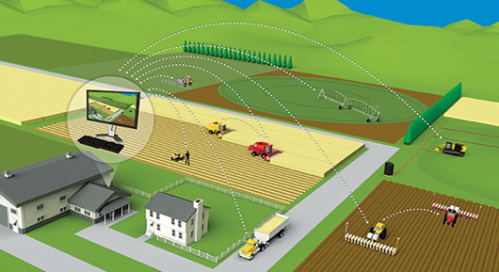

**Building Modules**

**Q2. Identify the major components required for designing the robotic systems for the theme assigned to you. (5)**

Green Weeder Robot:

* Mechanical systems
  1. 75 RPM DC Geared Motors (Quantity 2: Left and Right Motors) + Caster Wheel (For Support)

What? :

Converts Electrical energy into mechanical energy, manifested in form of rotational motion. It derives power from V Mot Supply rail. It is controlled by L293D dual motor driver which provides up to 600 mA of current to each motor. To change the direction of motion, direction control pins of L293D are manipulated while velocity control is achieved by using Pulse Width Modulation.

Use:

This component can be referred as legs of the bot. The bot will traverse the whole arena based on code which will manipulate the rotation direction and rotation speed of the two motors to change the direction of motion.

* Electronic Systems
  1. Position Encoders

What? :

This component will give the velocity / position feedback to the robot. It consists of slotted disc which rotates between optical encoder (optical transmitter and receiver). Optical encoder MOC7811 is used as position encoder on the robot.

Use:

The position feedback from the position encoder will be used to determine when to sense presence of a plant either to the right or to left of the line being traversed by the robot.

* 1. Sharp IR Sensors (Quantity 1)

What? :

This sensor will measure accurate distance by transmitting a narrow IR beam from the IR LED and measuring the angle of the reflected light using the CCD array. It gives same response to objects of different color as measured distance is function of angle of reflection and not of reflected light intensity. The IR LED and CCD array both are encapsulated in the housing with precision lens assembly mounted in front of them.

Use:

The sensor will help us to detect presence of a plant to either left or right of the object. Once presence is confirmed the color can be sensed to determine the necessary action to taken.

* 1. White Line Sensors (Quantity 3)

What? :

White line sensors will detect white line on the ground surface. The amount of light reflected by line of any other color other than white is less, minimum in case of black. It is used to give a sense of localization. It consists of a highly directional photo transistor for line sensing and bright red LED for illumination. Due to directional nature of photo diode it does not get affected by ambient light easily.

Use:

The amount of light reflected by a black line will be in high contrast compared to that of white surface. The stated fact can be used to maintain the robot on the path and also to detect the arrival of node. Since a node will make all the three white line sensors to register a high value whereas a path will do the same to only the middle sensor leaving the edge ones.

* 1. Color Sensors

What? :

A sensor used to identify the color of an object. It can be used to identify four colors which are red, blue, green and black. It generates a square waveform on being exposed to an object, the frequency of generated wave varies depending on the color of the object. Thus on basis of different frequencies one can identify the colors using a color sensor.

Use:

This sensor will help us to determine the color of any detected plant and hence decide the task to be carried out.

* 1. Xbee Module

What? :

These modules are embedded solutions providing wireless end-point connectivity to devices. They use the IEEE 802.15.14 networking protocol.

Use:

Xbee modules will help to reduce the no. of detections or sensing operations by providing a medium to transmit plant locations to different routers/bots. It will also be useful in navigation of the bot and averting any possibility of collision.

* Weeding system
  1. Servo Motors (Quantity 4)

What? :

A rotatory actuator that allows to control angular position. It consists of a suitable motor coupled to sensor for position feedback.

Use:

The servo motors will form an integral part of stalk gripping mechanism, it will help to bring the plant within the reach of end effectors, lower/raise the upper arm, catch weed stalk with the gripping fingers/end effectors of the robotic arm, and lift it to finally dump the stalk in a collection box on the other side of the robot.

* 1. Support structure

This is what will house the servo motors or drives, belts and will act as support structure for gripping and depositing weed plant stalk.

* 1. Collection box

All the stalks collected will be deposited in this cardboard box fixed on one side of the bot. Its base along with a mini servo motor will act as a gate to hold the deposited stalks together and dump it on the deposit zones.

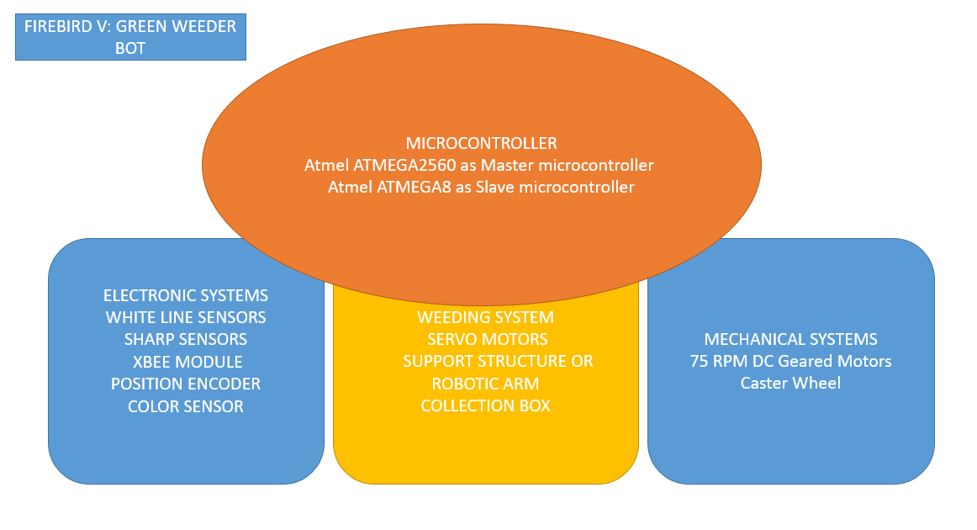

Blue and Red Feeder Robot:

* Mechanical systems
  1. 75 RPM DC Geared Motors (Quantity 2: Left and Right Motors) + Caster Wheel (For Support)

What? :

Converts Electrical energy into mechanical energy, manifested in form of rotational motion. It derives power from V Mot Supply rail. It is controlled by L293D dual motor driver which provides up to 600 mA of current to each motor. To change the direction of motion, direction control pins of L293D are manipulated while velocity control is achieved by using Pulse Width Modulation.

Use:

This component can be referred as legs of the bot. The bot will traverse the whole arena based on code which will manipulate the rotation direction and rotation speed of the two motors to change the direction of motion.

* Electronic Systems
  1. Position Encoders

What? :

This component will give the velocity / position feedback to the robot. It consists of slotted disc which rotates between optical encoder (optical transmitter and receiver). Optical encoder MOC7811 is used as position encoder on the robot.

Use:

The position feedback from the position encoder will be used to determine when to sense presence of a plant either to the right or to left of the line being traversed by the robot.

* 1. Sharp IR Sensors (Quantity 1)

What? :

This sensor will measure accurate distance by transmitting a narrow IR beam from the IR LED and measuring the angle of the reflected light using the CCD array. It gives same response to objects of different color as measured distance is function of angle of reflection and not of reflected light intensity. The IR LED and CCD array both are encapsulated in the housing with precision lens assembly mounted in front of them.

Use:

The sensor will help us to detect presence of a plant to either left or right of the object. Once presence is confirmed the color can be sensed to determine the necessary action to taken.

* 1. White Line Sensors (Quantity 3)

What? :

White line sensors will detect white line on the ground surface. The amount of light reflected by line of any other color other than white is less, minimum in case of black. It is used to give a sense of localization. It consists of a highly directional photo transistor for line sensing and bright red LED for illumination. Due to directional nature of photo diode it does not get affected by ambient light easily.

Use:

The amount of light reflected by a black line will be in high contrast compared to that of white surface. The stated fact can be used to maintain the robot on the path and also to detect the arrival of node. Since a node will make all the three white line sensors to register a high value whereas a path will do the same to only the middle sensor leaving the edge ones.

* 1. Color Sensors

What? :

A sensor used to identify the color of an object. It can be used to identify four colors which are red, blue, green and black. It generates a square waveform on being exposed to an object, the frequency of generated wave varies depending on the color of the object. Thus on basis of different frequencies one can identify the colors using a color sensor.

Use:

This sensor will help us to determine the color of any detected plant and hence decide the task to be carried out.

* 1. Xbee Module

What? :

These modules are embedded solutions providing wireless end-point connectivity to devices. They use the IEEE 802.15.14 networking protocol.

Use:

Xbee modules will help to reduce the no. of detections or sensing operations by providing a medium to transmit plant locations to different routers/bots. It will also be useful in navigation of the bot and averting any possibility of collision.

* Feeding system
  1. Servo Motors (Quantity 1)

What? :

A rotatory actuator that allows to control angular position. It consists of a suitable motor coupled to sensor for position feedback.

Use:

The servo motor used will play major role in controlled flow of fertilizer to plants. A gate

will be designed at the end of the spiral bead container, which opens and closes for a

short time interval ensuring only two or three fertilizing beads are deposited in the

plants.

* 1. Gate structure

This is where the servo motor gate will be placed and the flow is controlled. This will be constructed by half cutting the small portion of spiral container near the bottom end.

* 1. Spiral container

This is a spiral tube placed on the top of Spark V. One end of the spiral container will be for filling it with the beads and another for the outflow. This structure container is used to avoid the jamming of beads inside the container.

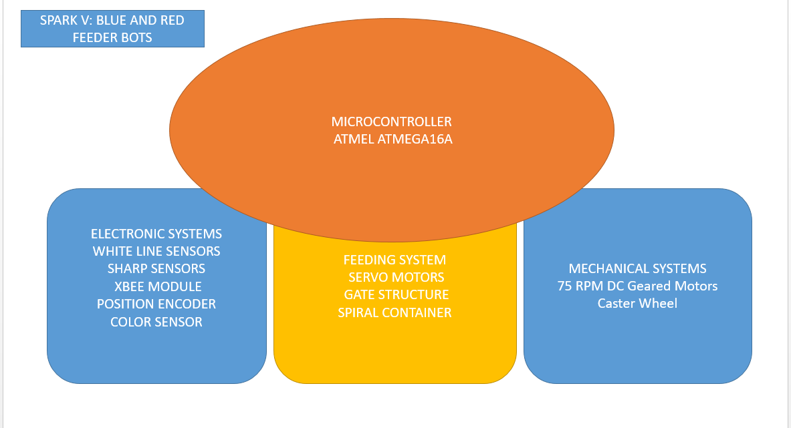

**Actuators**

**Q3. List all the actuators present on the Firebird V and Spark V robots provided to you. Besides the existing actuators, please mention any additional actuators that may be required for designing the robot system in your theme. Mention and justify the use of additional components. (5)**

Firebird V- Green Weeder Bot

Actuators already present:-

1. 75 RPM DC Geared Motors (Quantity 2: Left and Right Motors)

Actuators need to be interfaced:-

1. Mini servo Motors (Quantity 4)

3 servo motors or actuators or drives will be used in robotic arm to pluck or grasp the green plant’s stalk and deposit it in the collector box containing the fourth servo motor.

1. One of it will be placed at shoulder of the arm, right beneath the lower arm to provide forward and backward movement of the arm as a whole.
2. Second of the three will be at elbow joining the lower and upper arm and providing freedom to raise and lower the wrist.
3. The third one will be at wrist to grasp the stalk and release it above the box to collect all stalks and finally deposit it in the required place.
4. Fourth mini servo motor will be useful in controlling the opening and closing mechanism of the base of the collector. While traversing the arena the gate or base of the box will be shut and just on the deposit area it will open up to release all the stalks.

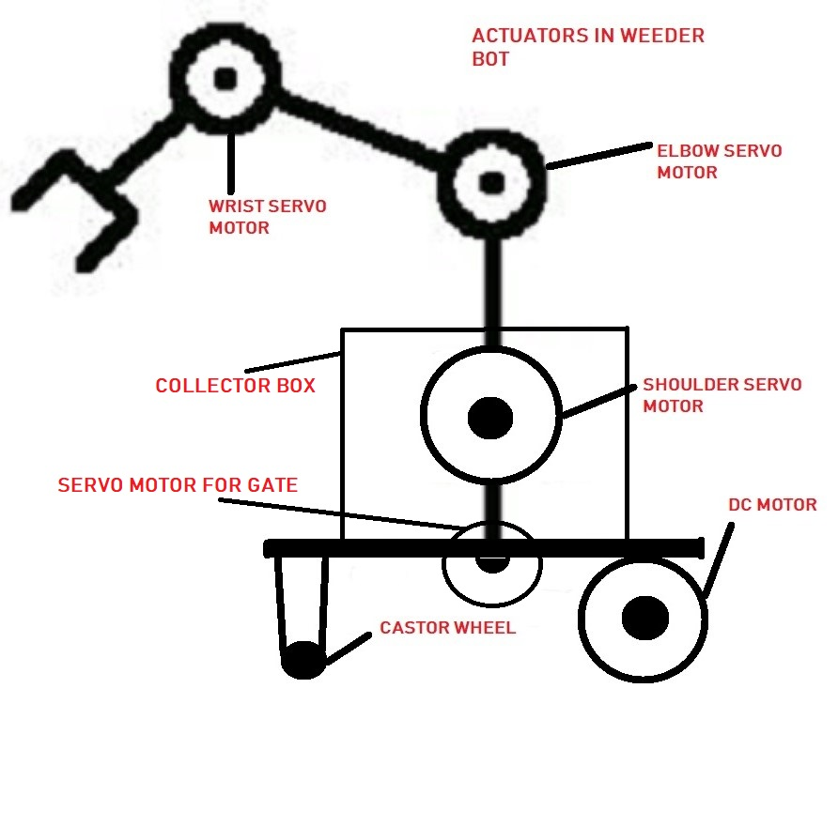

Spark V- Red and Blue Feeder Bot

Actuators already present:-

1. 75 RPM DC Geared Motors (Quantity 2: Left and Right Motors)

Actuators need to be interfaced:-

1. Servo Motor (Quantity 1)

This servo motor will be placed at one end of a spiral tube containing fertilizing beads.

It will control a small gate attached to its shaft to allow only one or two beads to pass and fertilize the plant.

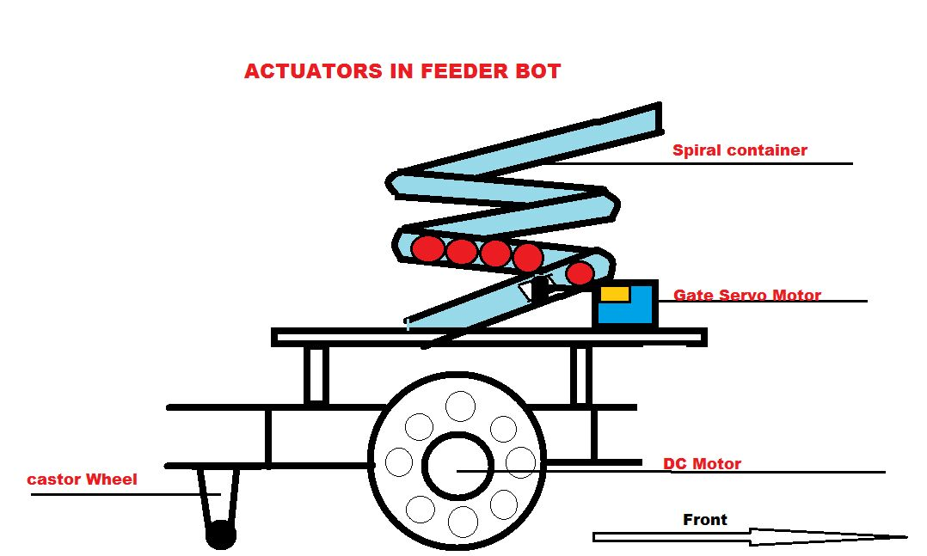

**Q4. Explain the design and working of the mechanism used for fertilizing the Plants (Blue or Red) and how it is mounted on a Spark V Robot. (5)**

Sensing Mechanism

Feeder robot will have a color sensor attached to the arm which is built over the right wheel of it. The feeder will recognize the color of the plant using this color sensor.

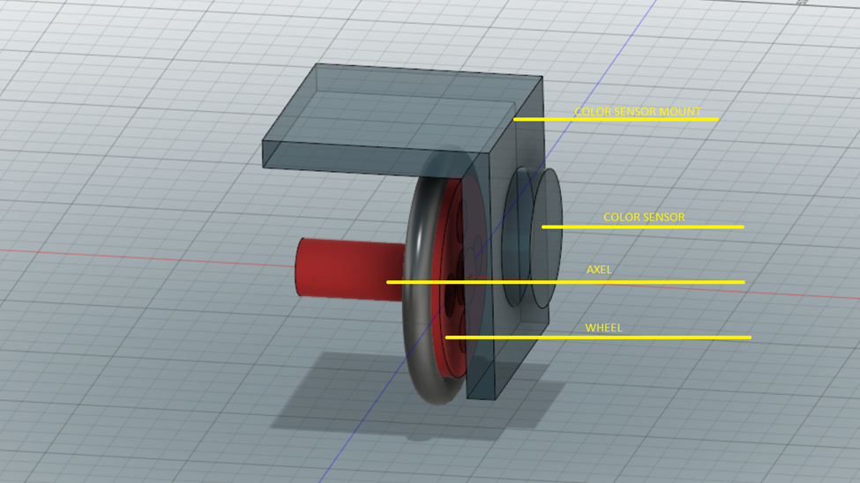

Feeder Mechanism

1. The Fertilizer beads will be stored in a spiral tube which will be mounted on the Spark V.
2. The inner diameter of the tube will be 1.3cm which is slightly more than the diameter of the beads (1.1cm).This ensures that the beads are stored in the tube one above the other. The height of the spiral structure will be 10cm and the diameter will be 8cm.
3. The tube will be filled from the upper end and the beads will flow out from the lower end of the spiral tube in a controlled manner.
4. The tube will be half-cut near its bottom end. A tiny gate will be arranged to this cut to which is in turn controlled by a micro servo motor.
5. While fertilizing a plant the gate will open and close in a very short time interval which will result in out flow of only one or two fertilizing beads.

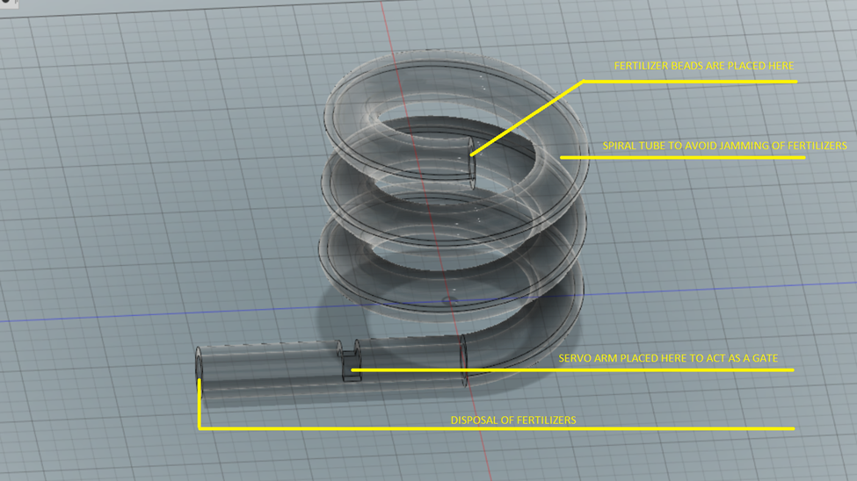

**Q5. Explain the design and working of the mechanism used for Weeding the Green Plants and how it is mounted on the Firebird V Robot. (5)**

**The gripping mechanism on the weeder bot consists of robotic arm and a collection box, i.e. collector.**

**Gripping mechanism and design:**

* 1. **It is a 3D printed shoulder (lower arm), elbow (Upper arm) and a wrist.**
  2. **The shoulder will have one servo motor giving the lower arm capability of moving 0-90 degrees from the bot’s porcelain surface.**
  3. **The elbow will be having another servo motor which will give the upper arm freedom of moving 0-90 degrees measured from the extended lower arm. The upper arm will be connected to the lower at elbow via the servo motor.**
  4. **The wrist will house a servo motor to grasp and release weeder plant’s stalk via end effectors which will be essentially a set of two fingers designed to hold the stalk firmly. The opening and closing of fingers will be possible with the help of two head gears at the end of fingers, one of which will be directly mounted on the shaft of servo motor while the other will be beside it along the shaft of the motor.**

**Collector (Collection box) design and mechanism:**

* **It is a cardboard cuboid having fixed walls on all the sides except the base which will be operated on by a servo motor to open and close the box from beneath. This will make storage of all the stalks possible and upon completing traversal of whole arena all stalks can be dumped on the demarcated “Deposit Area” by opening the box from beneath.**

**Way of Mounting:**

* **Robotic Arm**

**The lower arm will be fixed to the Firebird V platform with the help of screws and Studs.**

* **Collector:**

**The collection box will be placed on the porcelain surface and made immovable by double sided tape. Almost whole of the collection box will lie across the robots surface so that the stalks collected can be dumped on deposit zone.**

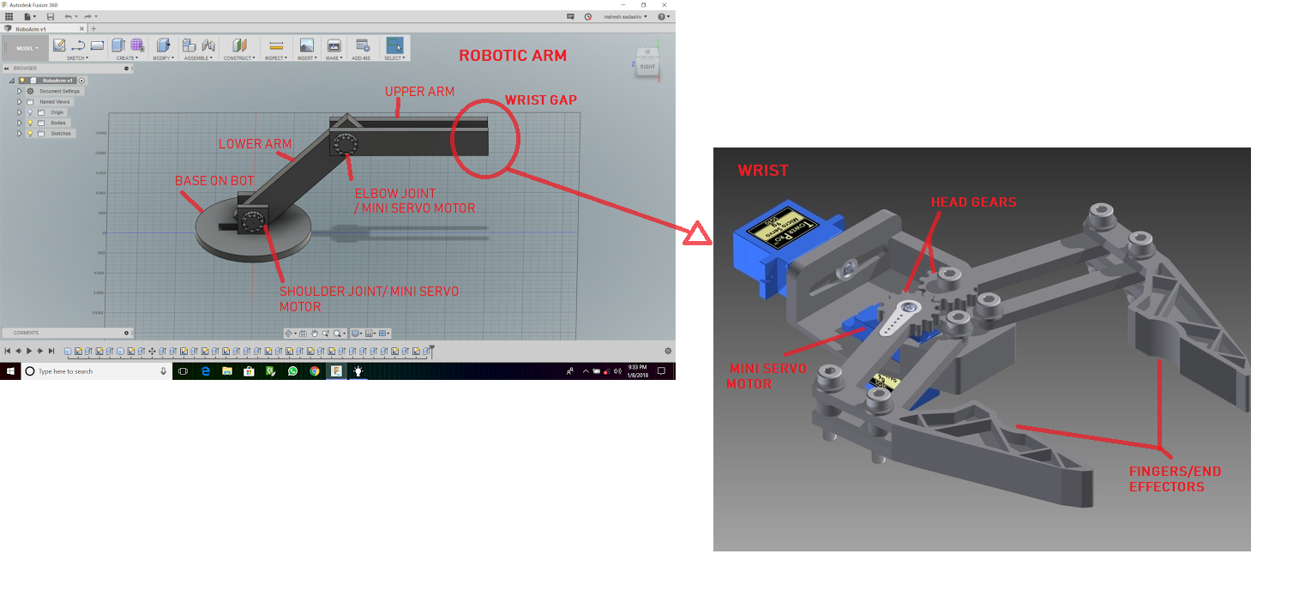

**Environment Sensing**

**Q6. Explain the functioning of the environment sensing technique used by Firebird V and Spark V robots in your theme. (5)**

**Environment sensing**

White line sensor:

Working:

It consists of a highly directional photo transistor for line sensing and bright red LED for illumination. Due to directional nature of the photo diode it does get effected by ambient light easily. The amount of light reflected by a black line will be in high contrast compared to that of white surface. The stated fact can be used to maintain the robot on the path and also to detect the arrival of node. Since a node will make all the three white line sensors to register a high value whereas a path will do the same to only the middle sensor leaving the edge ones.

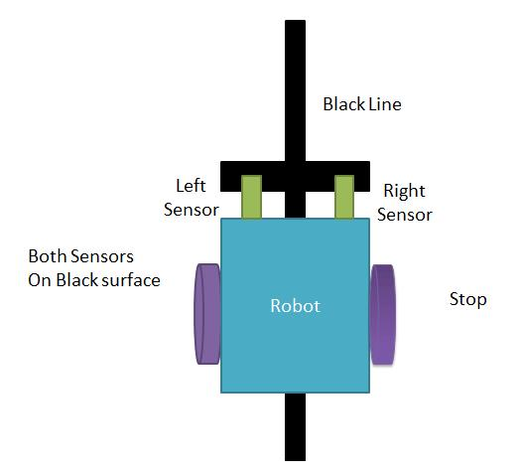 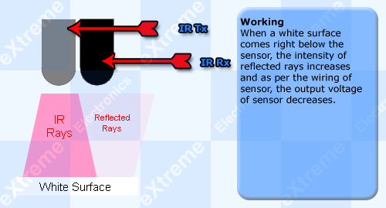

Use:

These sensors are used by the Firebird V (Weeder) and Spark V(Feeder) at every moment of their motion on the arena. The robots are required to follow the black path on the arena. So it is most important to use these white line sensors to sense the lines and nodes.

Sharp Sensors:

Working:

These sensors are used to measure accurate distance of the obstacle. Sharp IR sensors consists of IR LED and linear CCD array, both encapsulated in the housing with precision lens assembly mounted in front of them. IR LED with the help of lens transmit a narrow IR beam. When light hits the obstacle/object and reflects back to the linear CCD array, depending on the distance from the obstacle, angle of the reflected light varies. This angle is measured by CCD array to estimate the distance from the object. It gives same response to different colored objects as the functioning does not depend upon reflected light intensity.

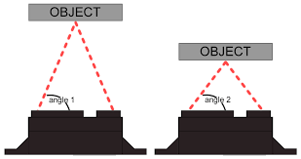

Use: In our problem the sharp sensors will detect the presence of plant either to the right or left of the

bot, once ensured of plant presence color sensors can identify and carry out the necessary task.

Color sensor:

Working:

The working of color sensor has been explained in detail in the following answer.

Use:

These sensors find the color of the object placed in front of it. In this theme these sensors are used by the weeder and feeders to recognize the type of the plant they come across.

**Q7. What is the principle of operation of the color sensor? Explain frequency scaling. Why is it necessary? (10)**

STRUCTURE OF THE SENSOR

The TCS230 color sensor senses light with the help of an 8x8 array of photo diodes, then using a current to frequency convertor the reading for the photo diodes are converter into a square wave with the frequency directly proportion to the light intensity, finally using the robot as output we can get the results for color. If we take a closer look at the sensor we can see how it detects various colors. The photo diode has 4 types of color filters , 16 of them have red filters ,16 filters for green,16 for blue filters and 16 photo diodes are clear with no filters, each of the 16 photo diodes are connected in parallel so using the 2 control pin S2 and S3 we can choose a specific filter. The chip has two other pins S0 and S1 to scale the output frequency. This frequency function allows the output of the sensor to be optimized for various frequency counters or microcontrollers

WORKING PRINCIPLE

The light sensor works by shining a white light at an object and then recording the reflected color. It can also record the intensity of the reflection (brightness). Through red, green and blue color filters the photodiode converts the amount of light to current. The converter then converts the current to voltage which our robot can read.

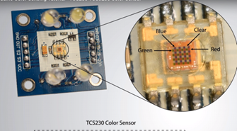 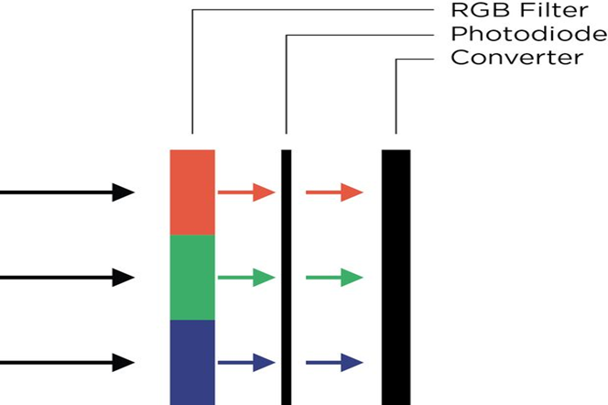

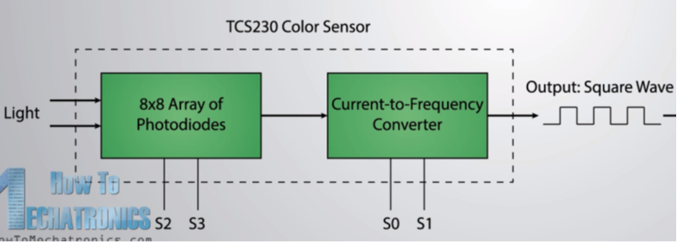

**Necessity**

    In the theme the robots are required to recognize the color of the plant since the feeders and the weeder can work on only on a specific color of plants. So it is necessary to use the color sensors to recognize the plants’ color.

**Q8. What is the difference between Red Plant and Green Plant? (5)**

The red plant is desired plant grown in the field and requires red fertilizer. The red plant is fertilized only by red feeder robot with red fertilizer (red colored beads). The green plant is a weed and is an undesired plant which is to be removed by the weeder robot.

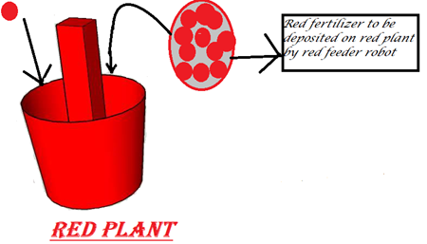 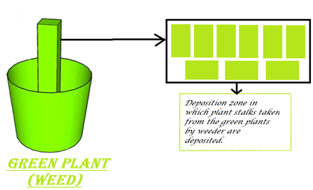

**Communication**

**Q9. Describe how you plan to implement communication between the three robots? What kind of information will they exchange and how frequently? Will this communication be uni-directional or bi-directional? Justify your answer. (5)**

**(Please read the algorithm to understand the meaning of terms used in this answer)**

**Roles of Robots**

1. **Firebird V/Green Weeder Bot: This robot will act as coordinator of the wireless network and will communicate in a bi-directional manner with all the other nodes of network.**
2. **Spark V/Red Feeder Bot: This robot will be router in the network and communicate in a bi-directional manner with rest of the nodes.**
3. **Spark V/Blue Feeder Bot: This robot will also be router in the network and communicate in a bi-directional manner with the others in network.**

**Data Exchange**

1. **The whole of arena is covered in 3 cycles, only when the end of a cycle is ensured, i.e. all the robots have reached their respective starting points for that particular cycle, the next cycle begins. In order to ensure that all bots have scanned their set of two rows for the cycle and reached their starting points, all the routers will communicate with the coordinator. After the communicated values mean the above the next cycle will begin. This type of communication will happen in total of 3 times.**
2. **After the end of first cycle all the three bots will store the plant locations and their colors. These locations will be sent to respective bots depending upon the detected colors of plants located there. The values at the receiver end will be stored to reduce the task completion time and hence make the algorithm more efficient. The following cycles will see the robots scanning only the required plants and doing the job on them. This type of communication will happen only once, right after the end of first cycle.**

**Q10. Describe the navigation scheme you will adopt for traversal of the three robots in the Arena. (10)**

**Navigation mechanism**

The navigation of three bots in the arena will be composed of different phases which are explained below.

**Phase 0**

In this phase the bots will reach their starting point from where they start phase1.Starting point will be reached in the path determined by considering the shortest and non-colliding (with the other robot) way.

**Phase 1**

The starting point for the bots are shown in the picture.

From the starting point the robots starts sensing the color of the plants on the right of the bot and do their respective work till the **A** node of same line is reached. Now the bot takes a 180degree turn and moves from A to G sensing and working on the plants on the right.

Here it is to be noted that the type of plants that is sensed by the Feeders and the Weeder will be stored in the memory of each robot. The required communication will be made through Zigbee.

Therefore by the end of the phase each bot will have finished their respective work in two rows.

Cycle 0

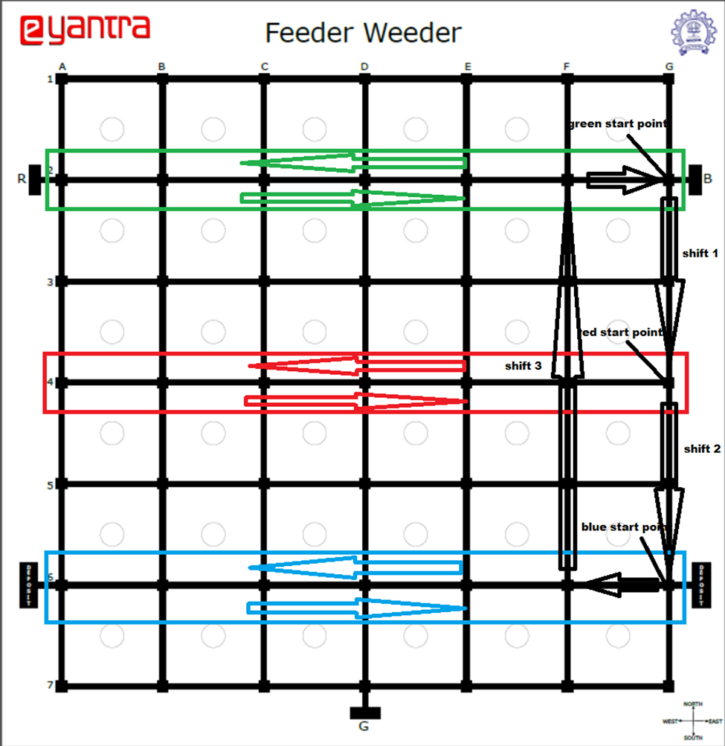

**Phase 2**

The Robots will switch their starting positions as shown in the figure.

Now the feeders and the weeder will again do their work as in Phase 1 from new starting points, but there is no need to test the color of plant at each circle since it is already done by the other bots and is stored in their memory. Therefore the robots will analyze the data stored in the memory through Zigbee and do their respective work.

**Cycle 1**

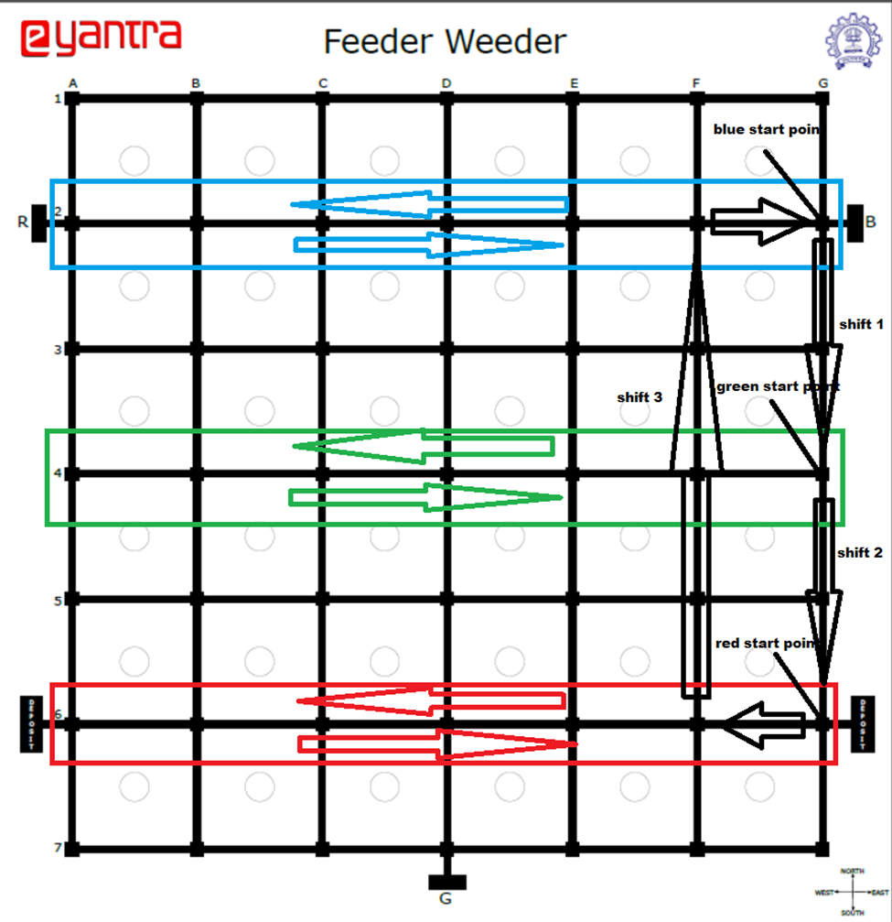

**Phase 3**

The Robots will again switch their starting positions .The phase 2 will be repeated with new starting points.

By the end of this phase, feeders will have finished feeding all their plants and Weeder will have removed and collected the all weeds.

Cycle 2

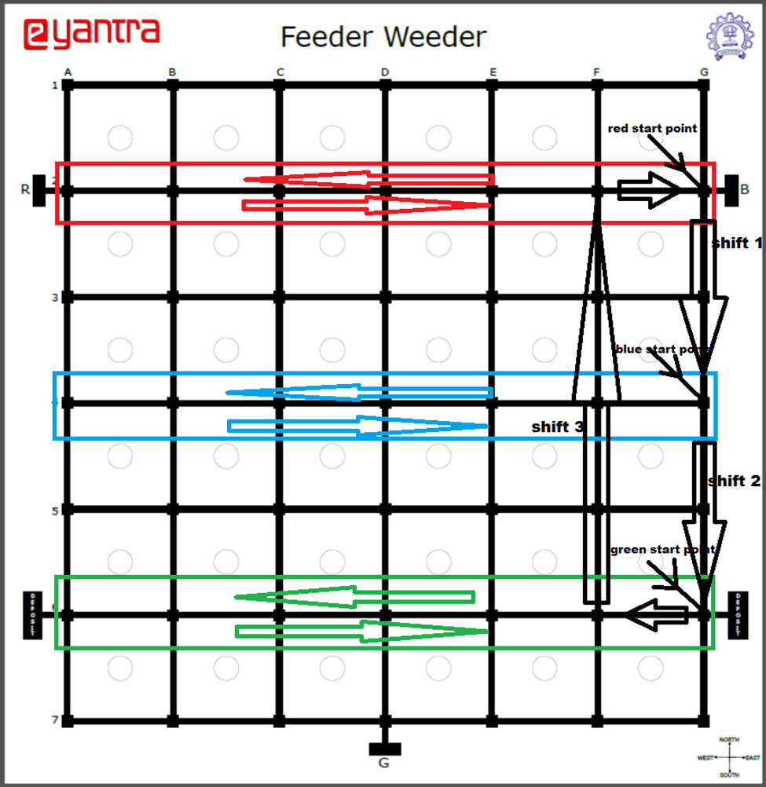

**Phase 4**

In this Phase feeders will reach their Homes. Weeder will deposit the collected weeds in either of the deposit zones and then reaches its home.

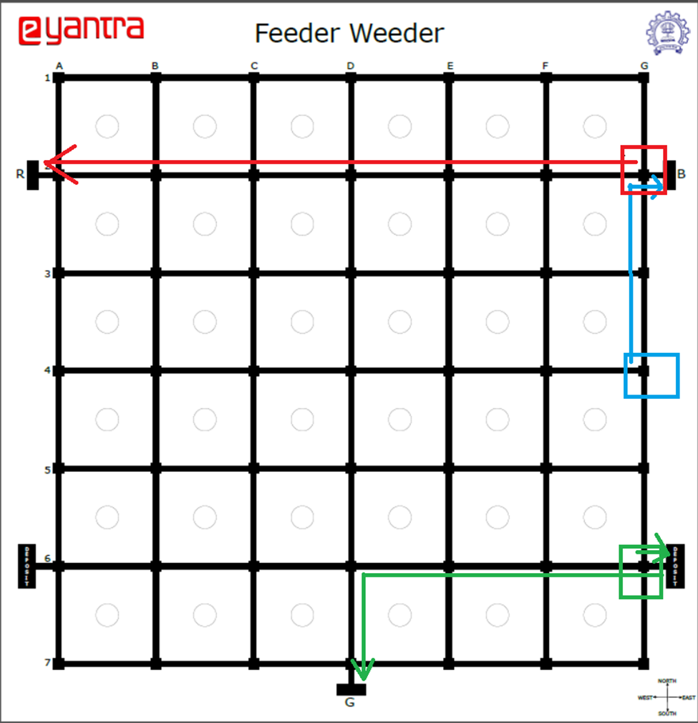

**Algorithm Analysis**

**Q11. Draw a flowchart to explain the algorithm you propose to use to complete the given task. (25)**

**Terms used to describe arena:**

1. **Set #**

**The whole of arena consisting of 36 boxes or locations for placing a plant has been divided into groups of 12 sequential boxes (as shown in figure). Each such group is called a ‘Set’ and are numbered starting from the top. # is a placeholder for numbers separating all the three sets.**

1. **Start-upper #**

**This points to the node from top-right corner of each set (as shown in figure). Every set will have this identifier and will be referred to using respective numbers. # is placeholder for numbers to differentiate between start-upper nodes of different sets.**

1. **Start-middle #**

**This points to the first right-middle node of each set (as shown in figure). Every set will have this identifier and will be referred to using respective numbers. # is placeholder for numbers to differentiate between start-middle nodes of different sets.**

1. **Cycle**

**The traversal of the bots has been divided into 3 cycles to ensure that each one goes through all the boxes or plant locations. Each cycle will have the bots assigned their set for scanning. During a particular cycle the bots will remain in their assigned set and carry on their work. Once all finish a job in their sets and return to their respective start-middle positions or nodes, they will navigate to the next uncovered set based on navigation rule already explained and hence the next cycle will begin. To traverse whole of the arena a total of 3 cycle will be required.**

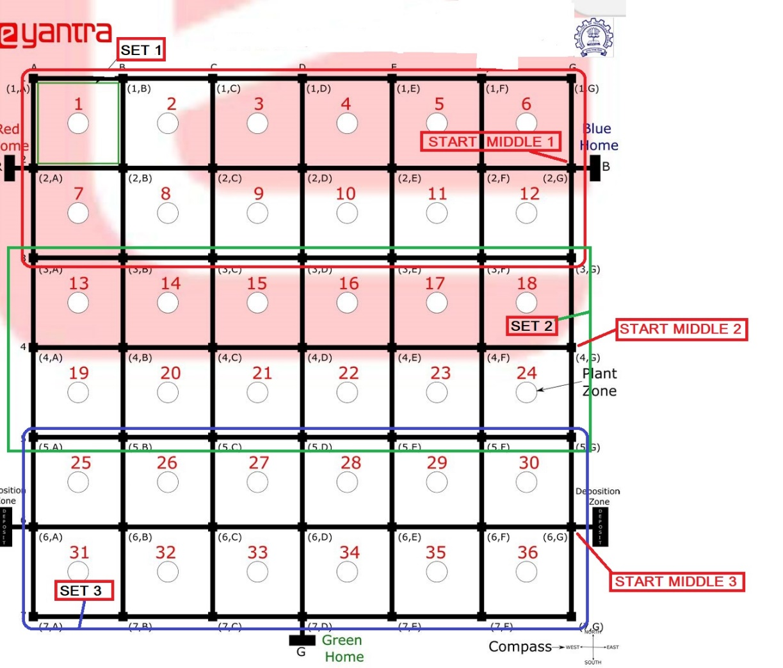

**Algorithm:**

**This part of the answer describes how all the three bots will go about traversing the whole of arena and coordinating between them to avoid collision and at the same time try to finish the task in least possible time.**

* **On being given the position and orientation to all the three robots at start, the algorithm will assign each bot their respective set for their first cycle (cycle_0). The assigning of set will be governed by their position, robot having the least sequential address will be given the least unassigned set.**
* **Once the sets are assigned and all of them take their start-middle positions, scanning of upper row of plant locations will begin which will be followed by scanning lower row of plant locations.**
* **During the first cycle (i.e. cycle_0) the robots won’t only scan and carry their actions on their respective plants but will also store locations of plants colored differently. Just before the end of cycle all the stored locations will be transmitted to different robots depending on the colors of plant. This will significantly reduce traversal and scanning time for the coming cycles as now the bots will be knowing which locations to go in each uncovered set.**
* **At the end of a cycle, when all robots have reached their respective start-middle positions again, based on the navigation rule already described they will be assigned their next set.**
* **The previous steps 2 and 4 will be repeated for three times after which first the green bot will go to its deposit zone to dump all the collected stalks and then to ‘Green Home’. Green weeder bot will be followed by Red feeder bot and finally the Blue Feeder bot.**
* **Once they reach their home positions, the bots will beep their buzzer for 5 seconds**

**A GENERAL LIST OF VARIABLES:**

1. **Green_location[]:** this array will store the location of all the green plants in uncovered sets after the completion of first cycle. Like this even red and blue location arrays will be created.
2. **Set_covered_Green[]:** this array will store the set numbers already covered by the green weeder bot. Like this even red and blue set_covered arrays will be created.
3. **End_reach**: this variable of Boolean type will keep track of whether the bot has reached the start-middle position again after scanning the upper and lower rows of boxes. The data of this variable will be communicated among the bots to decide when to begin the next cycle.
4. **Cycle**: this variable will keep track of the present cycle.
5. **Set_cover**: this variable will keep track of percentage of plant locations covered in set. It will have only two values 50 and 100. Former of the two specified value will denote that the bot has reached the other end of the set and completed scanning of upper row of plant locations, whereas the latter value i.e., 100 will suggest that the whole set has been scanned by the bot.

**FUNCTIONS AND PROGRAM FLOW:**

(Function description has been arranged in order of program flow)

1. Main()

This is the launch pad function. It will call all the other functions at their respective time to complete the task.

1. Pin_config()

Calling function will be main.

It will configure the pins for different hardware used like motors, LCD, sensors etc.

1. Traversal_start()

Calling function will be main.

It will contain all the functions which will implement the navigation, arena traversal, scanning plants, stalk collection, fertilizing of plants, rotate functions, Xbee communication, dumping of stalks and lastly home-run function.

1. Stage_0()

Calling function will be traversal_start().

This function will be called right at start of traversal_start() when cycle 0 is in place. It will assign set to different bots depending upon the sequential address and cause the robots to move to start-middle positions of their respective sets. It will wait for all bots to reach their positions and confirm the same over wireless Xbee module.

1. Stage_1()

Calling function will be traversal_start().

The function will start traversal of the sets by all the bots and scanning of plants in the upper/lower row blocks of their respective sets. When a match of color is found by any of the bots, fertilize function/weed function will be called. It will also blink the RGB LED accordingly. The traversal and scanning will continue till the bot has reached the other end of arena where the bot will call stage_2() function. It will call function navigate when value of set_cover is 100 and when value of cycle variable is less than 3. When cycle variable achieves a value of 3, it will denote the whole arena has been traversed by all the bots and hence navigate() function will call home_run() function.

During the execution of this function when cycle 0 is in place the bots won’t only scan the plants but will also store the locations of plants of unmatched colors. The stored locations will be later transmitted to destined bots just before end of cycle 0 when all blocks have been covered in all the sets.

1. Stage_2()

Calling function will be stage_1(). This function will be called only when set_cover is 0.

This function will rotate the bot by 180 degrees when the bot has covered half of the blocks in a set (when the bot has reached the other end of arena) and wait for all the other bots to do the same. Once a confirmation of above for all the other bots is achieved over Xbee, it will call stage_1() function again to traverse and scan the other half of blocks in the set. Before calling function stage_1() again it will update the value of set_cover variable to 50.

1. Navigate()

Calling function will be stage_1(). This function will be called by stage_1() only when set_cover is 100.

Navigate() on being called will first wait for all the bots to finish traversal of their set for the present cycle and reach start-middle position again. Once the said is ensured over Xbee it will change the sets of the bots according to the navigate algorithm already described. After changing the sets it will call the stage_1() function again after setting the value of set_cover variable back to zero.

1. Home_run()

Calling function will be Navigate(). This function will be called only when value of cycle variable is 3.

It will house 3 different functions called green_home(), red_home() and blue_home(). All the home functions will implement the traversal of robots from the start-middle positions to their respective home locations. In case of green weeder bot the green_home() function will first walk the robot to deposit zone and dump all the stalks there, following which the weeder bot will head to green home.

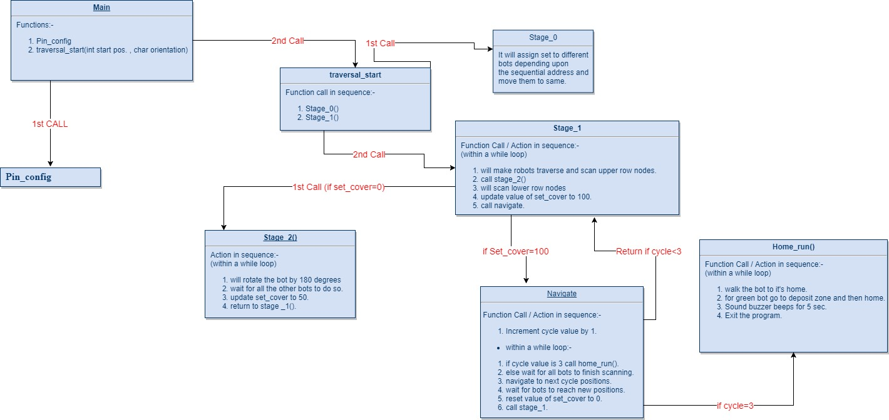

**Challenges**

**Q12. What are the major challenges that you anticipate in addressing this theme? How do you plan to overcome these challenges? (10)**

The Challenges that team is anticipating are mentioned below along with their possible solutions.

**1. Dealing with unfamiliar hardware**

Since the members of the team are studying computer science, we predict that team may have to use hardware which it has never used before. We strongly believe it as an opportunity for us to face and solve those problems which we would never learn from our course. We thank e-Yantra for the opportunity.

We look forward to solve this problem by dedicated study of the materials provided by e-Yantra and by posting our doubts in Piazza platform.

**2. Comparatively smaller community of ATMEGA and Firebird**

This would result us in lack of extra tutorials.

We would ask e-Yantra regarding our doubts. From our previous experience we know that team e-Yantra is very responsive.

1. **Managing the academics along with the e-Yantra**

E-Yantra needs dedicated work therefore all the tasks will require a lot of time. Which might result in the lack of time for academics work.

We will try to solve this with proper planning and reserving time for both.

**4. Implementing communication among robots**

Since this is the first time for all members in our team where we are dealing with implementing communication between three robots using Zigbee we believe there will be some technical issues in communication among the robots.

However, we will attempt to tackle this problem through a systematic procedure of trial and error as well as a thorough reading of Zigbee tutorials.

**5. Line Following**

PROBLEM

The line following algorithm given to us is a simple one, the robot always tends to stray of the track ever so slightly which sometimes causes it to miss the nodes. This could mess up the sequence of instructions given to it by the program.

SOLUTION

We will use a PID (Proportional, Integral and Derivative controller) control to fine tune the error correction and make the robot always be centered on the black line. This will cause the robot to never miss the nodes and the sequence of instructions will be executed properly.

**6. Collision Problem**

Although the algorithm has been designed to almost eliminate the situation of collision among the bots by taking in help of Xbee wireless communication. The navigation code if not properly implemented pose a breeding ground for this problem.

SOLUTION

Implementation of navigation code has to be carried out while considering all cases. The code has to be tested with an exhaustive set of trial cases to ensure its working in every scenario.